FOR IMMEDIATE RELEASE
Contact:
Diane Rumley
919-274-7344
Diane@SupportMilitarySpouses.org

Over One Thousand Military Spouses & Children to Receive Christmas Care Packages
Penske & Walmart Help Local Non-Profit to Deliver Smiles to Military Spouses & Children

Support Military Spouses to Make Special Deliveries Friday, December 4th

WHO: Media and special guests are invited to attend
WHAT: Support Military Spouses Christmas Care Packages delivery party.
Fayetteville military spouses and children will receive a free Christmas Care Package.
WHEN: Friday, December 4th, 2015 9:30am-11:00am
WHERE: AIT Festival Hall, 421 Maiden Lane Fayetteville, NC 28301
WHY: “Military spouses and their families sacrifice for the freedoms we enjoy,” said Dr. Steven and
Diane Rumley, Co-founders, Support Military Spouses. “By giving a
Christmas Care Package, we wish to say thank you on behalf of a grateful nation.”

ABOUT SUPPORT MILITARY SPOUSES:
Support Military Spouses goal is to recognize and applaud the undaunted courage of military wives and husbands as they shoulder the responsibility of family life, care for wounded warriors, and honor the memory of our nation’s fallen heroes. We do this with the help of patriotic volunteers, committed partners, and through programs that educate, appreciate and reaffirm the sacrifice, patriotism and selflessness of all military spouses. For more information visit www.SupportMilitarySpouses.org or call 919-274-7344.
CHRISTMAS CARE PACKAGES FOR MILITARY SPOUSES is the nation’s only program of its kind, is the flagship of Support Military Spouses. It is our vision and goal to assemble, collect, and distribute Christmas Care Packages filled with items that are encouraging in nature to every U.S. military wife or husband whose spouse is active duty. Support Military Spouses is a Christian non-profit organization. Visit www.SupportMilitarySpouses.org for details.
-more-

FOR IMMEDIATE RELEASE:
Contact:
Diane Rumley
919-274-7344 Diane@SupportMilitarySpouses.org
FAYETTEVILLE, NC – The countless daily sacrifices that military spouses and their children make are often underappreciated or overlooked.
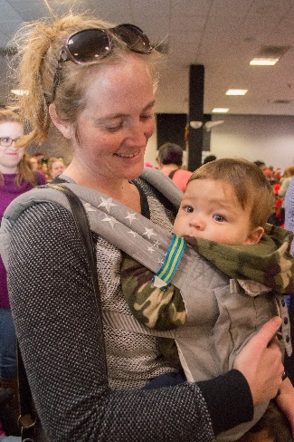
One unique non-profit organization is doing all it can to rectify that oversight. On Friday, December 4th, at 9:30 am Support Military Spouses will be at the AIT Festival Hall to deliver over one thousand Christmas Care Packages for Military Spouses and Children.
Hundreds of volunteers throughout North and South Carolina assembled the Christmas Care Packages destined for military families in Fayetteville.
The assembly-line effort is part of the Appreciation Care Packages program organized by Support Military Spouses.
The program, whose main focus is on military spouses, is the only kind in the nation.
Support Military Spouses Co-Founders Dr. Steven and Mrs. Diane Rumley said, “This program is a way to recognize and appreciate the multitude of challenges facing spouses and their children especially during the Christmas season.”
Each Christmas Care Package for a military spouse contains a wide array of gifts, including jewelry and a New Testament. Each Christmas Care Package for a military child also an assortment of gifts, as well, which all include a Book about Jesus.
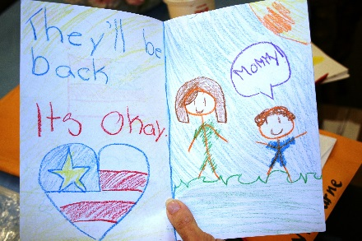
“But just as importantly,” said the Rumley’s, “each package carries a personal handwritten card. Those heartfelt messages, penned by thousands of Carolina school children and patriotic adults, have made an emotional impact on the military families in the past years.”
Now in its seventh year, Support Military Spouses is expanding an already strong relationship with military families.
The organization serves NC military bases Fort Bragg, Camp Lejeune, Seymour Johnson AFB, SC military bases Joint Base Charleston, Fort Jackson, Shaw AFB, and GA military base Moody AFB.
The organization has implemented two programs to help spouses improve their financial knowledge and work skills including hosting military spouse job fairs.
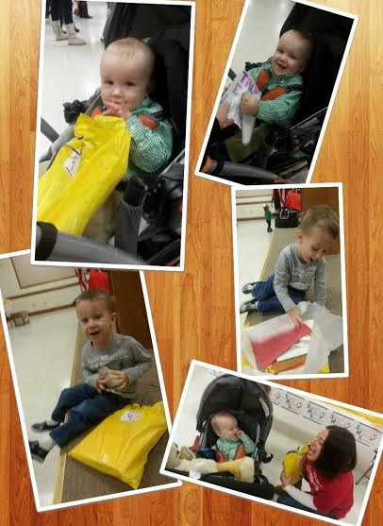
Money Management Workshops aim to help spouses build a strong credit score, provide tips for credit card usage and teach proper budgeting through workshops.
Job Skills Training provides useful skills on resume writing, proper usage of social media and job research. Support Military Spouses hosts Job Fairs exclusively for spouses, connecting qualified military spouses with military friendly employers.
Both programs are offered near the military bases. In addition, spouses have access to program information and tips via webinars, emails and social media.
Spouses interested in registering for any Support Military Spouses programs can visit www.SupportMilitarySpouses.org
Support
Support Military Spouses acknowledges the help and support of all their community partners and sponsors. The generosity of Penske, the Walmart Foundation, Wells Fargo, Hallmark, McDonalds, American Bible Society, Duke Energy Foundation, Fort Bragg Federal Credit Union and Fayetteville New Car Dealer Association ensured that over a thousand deserving military spouses and children received encouragement in the form of a Christmas Care Package to brighten the holidays.
About Support Military Spouses
Support Military Spouses goal is to recognize and applaud the undaunted courage of military wives and husbands as they shoulder the responsibility of family life, care for wounded warriors, and honor the memory of our nation’s fallen heroes. We do this with the help of patriotic volunteers, committed partners, and through programs that educate, appreciate and reaffirm the sacrifice, patriotism and selflessness of all military spouses. For more information visit www.SupportMilitarySpouses.org or call 919-274-7344.
For information on making a donation, please visit www.SupportMilitarySpouses.org.

###

