Military Spouses in Jacksonville to Receive Appreciation Care Packages
Support Military Spouses to Make Special Deliveries Wednesday, April 13th
WHO: Media and Military Spouses are invited to attend
WHAT: Support Military Spouses Appreciation Care Packages delivery party.
Jacksonville military spouses will receive a free Appreciation Care Package.
WHEN: Wednesday, April 13th, 2016 10:30am-11:30am
WHERE: Jacksonville Conference Center – 800 New Bridge St, Jacksonville, NC 28540
WHY: “Military spouses and their families sacrifice for the freedoms we enjoy,” said Dr. Steven and
Diane Rumley, Co-founders, Support Military Spouses. “By giving a
Care Package, we wish to say thank you on behalf of a grateful nation.”
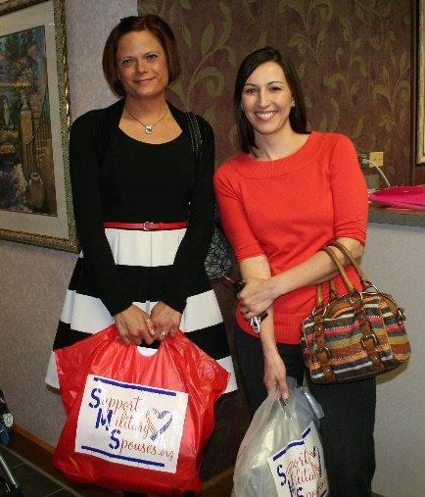
ABOUT:
Support Military Spouses goal is to recognize and applaud the undaunted courage of military wives and husbands as they shoulder the responsibility of family life, care for wounded warriors, and honor the memory of our nation’s fallen heroes. We do this with the help of patriotic volunteers, committed partners, and through programs that educate, appreciate and reaffirm the sacrifice, patriotism and selflessness of all military spouses.
Appreciation Care Packages for military spouses, the nation’s only program of its kind, is the flagship of Support Military Spouses. It is our vision and goal to assemble, collect, and distribute Appreciation Care Packages filled with items that are encouraging in nature to every U.S. military wife or husband whose spouse is active duty. Support Military Spouses is a Christian non-profit organization. For more information or to make a donation, visit www.SupportMilitarySpouses.org or call 919-274-7344.
SUPPORT:
Support Military Spouses acknowledges the help and support of all their community partners and sponsors. The generosity of Penske, the Walmart Foundation, Wells Fargo, Hallmark, Mattel, Bob 93.3, Your Country 95.1, The Wolf 92.3/101.1, Rock 105.5 and American Bible Society ensures deserving military spouses receive encouragement in the form of an Appreciation Care Package.

JACKSONVILLE, NC – The countless daily sacrifices that military spouses and their families make are often underappreciated or overlooked.
One unique non-profit organization is doing all it can to rectify that oversight. On Wednesday, April 13th, at 10:30am, Support Military Spouses will be at the Jacksonville Conference Center to deliver Care Packages for Military Spouses.
Volunteers throughout North and South Carolina assembled the Appreciation Care Packages destined for the military spouses in Jacksonville.
The assembly-line effort is part of the Appreciation Care Packages program organized by Support Military Spouses.
The program, whose main focus is on military spouses, is the only kind in the nation.
Support Military Spouses Co-Founders Dr. Steven and Mrs. Diane Rumley said, “This program is a way to recognize and appreciate the multitude of challenged the spouses face.”
Each Appreciation Care Package for a military spouse contains a wide array of gifts, including jewelry and a New Testament.
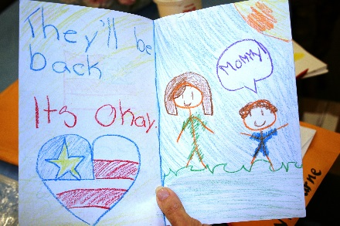
“But just as importantly,” said the Rumleys, “each package carries a personal handwritten card. Those heartfelt messages, penned by thousands of Carolina school children and patriotic adults, have made an emotional impact on the military families in the past years.”
Now in its eighth year, Support Military Spouses is expanding an already strong relationship with military families.
The organization serves NC military bases Camp Lejeune, Seymour Johnson AFB, Fort Bragg, SC military bases Joint Base Charleston, Fort Jackson, Shaw AFB, and GA military base Moody AFB. The organization has implemented two programs to help spouses, active duty service members, and veterans improve their financial knowledge and work skills including hosting military spouse job fairs.
Money Management Workshops aim to help attendees build a strong credit score, provide tips for credit card usage and teach proper budgeting through workshops.
Job Skills Training provides useful skills on resume writing, proper usage of social media and job research. Support Military Spouses hosts Military Community Job Fairs connecting qualified active duty service members, military spouses, and veterans with military friendly employers.
Both programs are offered near the military bases. In addition, program information is available via webinars, emails, and social media.
Individuals interested in registering for any Support Military Spouses programs can visit www.SupportMilitarySpouses.org
###

